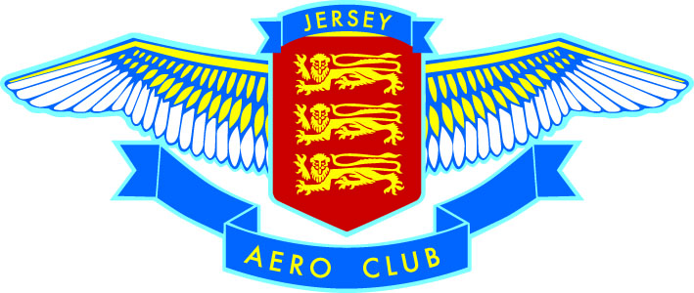

FACILITY FEES

Dear Flyers,

Please be advised that from 1st December 2017, all NON JERSEY based aircraft will be required to pay a facility fee of £7.50

Jersey Aero Club Committee

